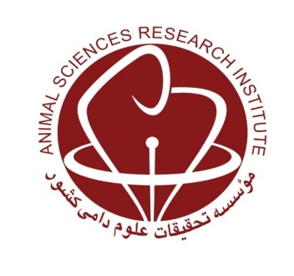
MINISTRY OF JIHAD-E-AGRICULTURE

Agricultural Research, Education and Extension Organization
Kerman Agricultural and Natural Resources Research and Education Center

Defining Breeding Goal and Selection Strategy for Rayeni Goat in Pasture System

Research worker: Najmeh Kargar Borzi

Abstract

In the present study a deterministic bio-economic model was used to estimate economic values for reproduction traits, production traits and longevity, from recording of 10 Rayeni Cashmere goat flocks including 1810 does and 95 bucks in Kerman province. The total annual profit of the flock was obtained as the difference between costs and revenues of the system. Costs included: feed, management and fixed costs. Revenues were derived from sale of culling does and bucks, excess kids, cashmere and milk. Among inputs (costs), labor cost constituted 48.6% of total costs while cost of feed was the second largest source of costs (48.0%). Revenue sources of production system included: live weight, milk and cashmere production, while live weight (62.4%) and milk production (29.3%) were the most important. Total profit was 3785003.5 Rial per doe per year. The most important traits were milk weight followed by litter size with relative importance of 0.545 and 0.097, respectively. The lowest relative importance was body weight of doe (-0.152). Changes in prices of input and output had slightly effects on economic values. The real data, phenotypic and genetic (co)variance matrix and means of traits were used to simulate base population. Five economic selection indices and four desired gain selection indices with different herd size and buck ratio were proposed. The traits included in each index were: BWD (body weight of doe), MW (milk weight), CW (cashmere weight), WK (body weight of kids sold) and NK (litter size). The maximum values of aggregate genotype, inbreeding average, genetic and economic gains were obtained in herd size of 400 and buck ratio of 0.04. The highest genetic gain and accuracy of selection index were obtained under index 1, included BWD, MW, CW, WK and NK traits while the highest amount of aggregate genotype and economic gain were acquired under index 2, included MW, CW, WK and NK traits.

Keywords: Breeding objectives; Economic values; Rayeni Cashmere goat.

