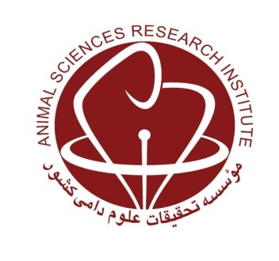
MINISTRY OF JIHAD-E-AGRICULTURE
Agricultural Research, Education and Extension Organization
Agriculture and Natural Resources Research and Education Center of Khuzestan

Monitoring and registration of the Najdi cattle population

Research worker: Bahareh Taheri Dezfuli

Abstract
Nowadays, native livestock that are adapted to poor quality food and pasture, pathogens, poor management and inadequate status of barn, are rapidly threatened with extinction through two factors of replacement and uncontrolled crossbreeding due to their inability to compete with imported livestock with high production. Over the years, Najdi cow has adapted to hot and dry climates and limited food resources. Given the crossbreeding that has taken place, the overall population trend of this breed is declining, and therefore the need for planning to maintain this breed is absolutely necessary. Therefore, in this study, herds which had Najdi cow with high purity percentage were identified and among them, 53 herds with a population of 100 male and female Najdi cattle were studied. Based on the data collected during the project, as well as the results of the Najdi Cattle Station, the average of appearance traits, weight, production and reproduction traits were estimated. Due to the age of puberty in Najdi cows at 13-15 months of age, the only record of traits which available after puberty was at 18 month of age. So, the average of body length, body height, heart girth and rump width of females in 18 month of age were 92.52cm, 112.67cm, 133.14cm and 31.42cm and the average of body length, body height and heart girth of males in the same age were 101.92cm, 119.47cm and 128.58cm which were more than the traits in females. Based on collected data, these body dimensions increased until the age of three. Based on these results, the average of birth weight, weaning weight, 12-month weight, puberty weight and 24-month weight were 19.04, 68.23, 127.70, 150.44 and 230.26 kg for males, respectively and 17.53, 62.62, 119.19, 214.23 and 137.44 kg for females, respectively. The results from Najdi Cattle Satation showed that the average of age at first mating, age at first calving, length of pregnancy and calving interval for Najdi cows were 703.51, 998.01, 283.01 and 391.88 days, respectively. Based on collected data, Najdi cows had low daily milk production, with the average of 1.95 kg which was estimated for all records in different parities (ranging from 1 kg to 6.9 kg/day). The responses provided by the farmers showed that most stated reasons for breeding of this breed were using low quality forage and its heat resistant to Khuzestan climate, especially resistance to disease and no mortality. However, in spite of pointing to the positive characteristics of this native livestock, most breeders were not satisfied from its low milk production and stated that fattening of its calves was also not profitable because the calves did not grow much. As mentioned, some researches have been done in the past on the identification and production and reproduction potential of Najdi cows, and this study has been done to investigate the current situation of this breed, its current distribution and use of past information for national registration of Najdi breed. Also, considering that among the farmers who were questioned, most of them referred to its easy rearing in the heat of Khuzestan, it seems that racial reform activities are necessary to maintain this breed and then improve its performance.
KeyWords: Genetic resourses, Najdi cattle, appereance charectristics, monitoring, Khuzestan.

