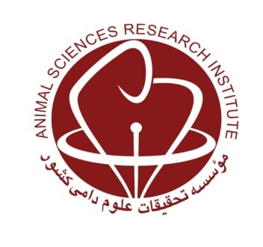
MINISTRY OF JIHAD-E-AGRICULTURE
Agricultural Research, Education and Extension Organization
Agriculture and Natural Resources Research and Education Center of Khuzestan

Estimation of some population parameters and inbreeding rate of Khuzestan province sheep flocks

Research worker: Bahareh Taheri Dezfuli

Abstract
In this study, in order to estimate some population parameters and inbreeding rate in sheep flocks of Khuzestan province, information of 100 flocks from different rearing systemswith two breeds of Arabic and Lori-Bakhtiari sheep were used during the years 2017to2019. The data were collected through a questionnaire using data from the last year informationand interview with the farmers. flocks' data was analyzed by SAS 9.1 software. The results showed that the average number of breeding ewes, the number of breeding rams, the duration of the ram stay in the flock and ram to ewe ratio were 173.67 heads, 9.56 heads, 5.96 years and 5.65 %, respectively, and 54% of the flocks had at least one lamb with a genetic abnormality. Accordingly, the effective size and the rate of inbreeding were 34.9 heads and 3% per generation, respectively. The effect of city was significant on most of the studied population parameters. In general, the results showed that the estimated effective size was less than the recommended minimum size by FAO (50 heads) for having less than 1% inbreeding per generation. So, it was caused to having flocks with inbreeding rate which is 3 times more than the permissible rate. Increasing of the flocks can decrease production performance, reproductive performance and increase genetic abnormalities. Therefore, based on the estimated inbreeding rate for flocks in the province, it is necessary to prevent further increasing in this inbreeding rate and its negative consequences by training farmers about issues such as suitable ram to ewe ratio, supplying breeding rams from out of the flock and keeping rams in flock for a shorter period of time, as well as, using rotational mating scheme.
KeyWords:Arabic Sheep, inbreeding,Farmer flocks, Lori Bakhtiari sheep, Khuzestan

