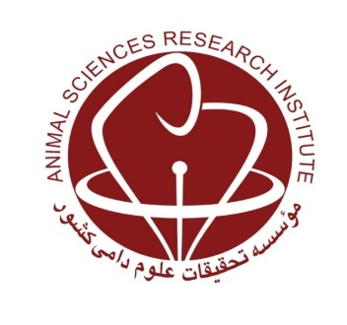
MINISTRY OF JIHAD-E-AGRICULTURE
Agricultural Research, Education and Extension Organization
Agriculture and Natural Resources Research and Education Center of Lorestan

Effect of forage type, concentrate level and canoula grain supplementation on feedlot performance, carcass quantity and quality traits of Lori male lambs

Research worker: Behrouz Yarahmadi

Abstract
This research was conducted to investigate the effect of type of forage (alfalfa or sainfoin) and canola seed (raw and roasted) with along diet concentrate level on growth performance and carcass characteristics of Lori male lambs. Accordingly, 108 male of Lori lamb with a mean live weight of 30±3.45 kg were selected. Treatments included two levels of forage (alfalfa and sainfoin) and two levels of canola seed (raw and roasted) with along diet three levels of concentrate (60, 70 and 80%). The experiment was conducted as factorial with completely randomized design (2×3×2) with three replications. The results showed that the effect of forage (alfalfa or sainfoin) and canola seed (raw and roasted) with dietary concentrate level on daily gain and feed conversion were significant (P<0.05). There was no significant difference between the above groups in terms of daily dry matter intake of lambs (P>0.05). The highest daily gain and feed conversion ratio were 224 g and 5.44 in lamb fed with sainfoin and roasted canola seed along with 70% concentrate respectively. The use of roasted canola in the diet increased the daily weight gain, which was in treatments with roasted canola higher than raw canola treatments. The effect of forage (alfalfa or sainfoin) and canola seed (raw and roasted) with dietary concentrate level had a significant effect on the percentage of lean meat, total carcass fat and the percentage of cold and hot carcasses (P<0.05). The highest carcass yield (48.25%), cold carcass weight without fat-tail, percentage of carcass and lean meat (58.56%) were related to lamb fed with sainfoin and 70% concentrate. The production cost per kilo gram of carcass and lean meat of lambs fed sainfoin and 70% concentrate were lower than other treatments. The results showed qualitative properties such as pH, chemical composition and meat color were not affected by diets (P>0.05). In general, with regard to the information obtained in this study and taking into account feed conversion ratio, daily gain, better carcass traits and total cost per kg carcass weight gain and traits, lambs fed with sainfoin and 70% concentrate Recommended with roasted canola seed better than others a recommendable treatment was recommended.
Key words: Sainfoin, Lori lamb, Canola seed, Carcass characteristics, Performance, Concentrate

