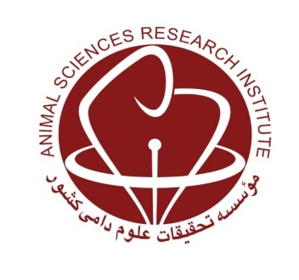
MINISTRY OF JIHAD-E-AGRICULTURE
Agricultural Research, Education and Extension Organization
Agriculture and Natural Resources Research and Education Center of Qazvin

Preparation of a comprehensive plan for locating poultry farms and related industries using the Geographic Information System (GIS) in Qazvin Province

Research worker: Masoud Mostashari

Abstract
Spatial planning is a long-term development program and it constitutes the basis of national and regional planning in country. The goal of spatial planning is to optimally distribute the population and activities in the land, so that each region is able to benefit from a range of economic and social activities in proportion to its capabilities, needs and location. The Deputy Minister of Livestock Affairs needs information from poultry farms for his long-term and short-term planning. The location information of poultry farms is one of the most important things to consider before making any policy decisions. The purpose of the project is to locate and determine the distribution map of poultry farms and units affiliated to this sector in Qazvin province. In the first stage, the available information was collected, then the location and necessary specifications for all breeding units and poultry related industries were determined through field visits. More than 800 geographical points were recorded in this project. Finally, using the GIS software, a map of the distribution of poultry farms in the province was prepared and the information of each unit was attached to it. The results showed that there was a high density in some areas of the province (Qazvin, Takestan and Abyek) and instead in some areas the number of poultry farms is very small (Alamout and Avaj). On the other hand, in the event of an infectious disease, it is easy to use these zoning maps and locate information on access routes, environmental complications, and neighboring units.
Keywords: Ghazvin Province , Geographic Information System , Location, Poultry

