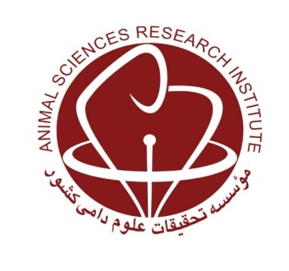
MINISTRY OF JIHAD-E-AGRICULTURE
Agricultural Research, Education and Extension Organization
Agriculture and Natural Resources Research and Education Center of Qom

Investigating of processed bentonite in solubilizing of essential oil in drinking water of broiler chicks, in comparison with Tween

Research worker: Mohammad Yeganeparast and Alireza Aghashahi

Abstract
In order to investigate the effects of processed bentonite on the solubilization of savory essential oil in broiler chickens' drinking water compared to Tween alcohol, this study was conducted in a completely randomized experimental design with 4 treatments and 4 replications using 320 commercial male Ross 308 chicks upto 42 days. Experimental treatments were: 1- control group, 2- drinking water containing herbal compound called Oregostim (as positive control), 3- drinking water containing 300 mg of savory essential oil per liter homogenized with bentonite emulsifier, and 4 - Drinking water containing 300 mg of savory essential oil per liter homogenized with emulsion of Tween alcohol.
During the experiment, the chicks were reared on the substrate and water and donor were freely available. Feed intake and weight gain were recorded weekly, and the number and weight of chickens were recorded daily and feed conversion ratio was calculated. The amount of drinking water consumed by the chickens was measured on the tenth, twentieth, thirty and forty days of breeding. At 28 days of age, the immune response of chickens to DNCB solution (di-Nitro Chloro Benzene) was assessed. At the age of 35 days, one bird was sampled at each experimental unit and blood samples were taken for red blood cells and platelets, hemoglobin and hematocrit percentages, blood lipids, cholesterol, some liver enzymes, white blood cell counts and the frequency of their types and Newcastle titer were evaluated. At the end of the experiment, each bird was randomly slaughtered and carcass yield, relative weights of main carcass and domestic offspring relative to live weight and qualitative characteristics of breast meat (including water holding capacity, malondialdehyde concentration, pH Immediately and two hours after slaughter) were measured.
This study showed that there was a significant difference only between the mean of among treatments in terms of feed intake and feed conversion ratio in the first and second weeks of rearing, first week weight gain and blood Newcastle titers. Among treatments containing savory essential oil dissolved in potable water with emulsifier tween or bentonite, only the second week of feed intake in the experimental group receiving safflower essential oil and bentonite and Newcastle titer in the experimental group receiving safflower essential oil and tween were significantly higher (P <0.05). Therefore, as a general conclusion, insertation of savory essential oil in drinking water as well as drinking water containing Oregostim, could not have a beneficial effect on the production indices and other parameters studied, But savory essential oil.improved liver health and carcass efficiency (P >0.05). Bentonite also played a good emulsifier role in dissolving savory essential oil in drinking water.
Keywords: Broiler, Savory essential oil, Solvent, Tween alcohol, Bentonite, Oregostim

