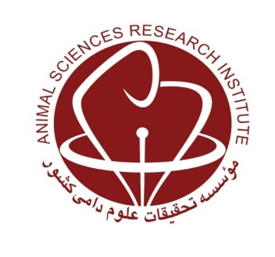
MINISTRY OF JIHAD-E-AGRICULTURE
Agricultural Research, Education and Extension Organization
Agriculture and Natural Resources Research and Education Center of Kurdistan

Utilization of potato aerial parts in complete feed block in diet of fattening male lambs

Research worker: Saleh Salehi

Abstract
Due to the growing population and more need for livestock products and the limitation of major sources of production such as land and water for forage production, the use of agricultural residues in ruminant feeding can be a useful alternative to overcome the challenge of recent years, including Drought and lack of forage.
On the other hand, considering that 60 to 70 percent of the cost of animal husbandry is nutrition, any improvement in nutrition management and efficiency in this sector will increase productivity. The aim of this study was to apply the aerial parts of potato in the preparation of complete feed block and optimum use of this residue as well as reduction of feed cost. The test treatments included the complete feed block with 15, 25 and 35 % of the potato aerial parts with the same energy and protein levels, which were the first, second and third treatments respectively.
This research was conducted for 90 days on eighteen seven-month-old Kurdish male lambs of plain area with average weight of 32.3 kg in a completely random design in three treatments and six replicate. In this study, the characteristics of the growth, feed consumption and the carcass characteristics of the lambs were investigated.
The initial body weights of the animals received complete feed blocks in the three rations were 31.67, 33.1 and 32.15 kg respectively but the final weights were 50.42, 50.07 and 48.12 kg respectively. Total live weight gain was 18.8, 17 and 16 kg that were significantly (p<0.05) different between the experimental blocks
The results showed that the average daily weight gain in the first, second and third treatments were 250, 226 and 213, respectively that differed significantly between the three treatments (p<0.05). The average dry matter intake for three treatments were 1.62, 1.51 and 1.57 kg respectively, the difference between the first and second treatments was significant (p<0.05), but the third treatment was not significantly different from the first and second treatments.
The average feed conversion ratio of the lambs fed with diets containing 15, 25, and 35 percent potato foliage in the complete feed blocks were 7.8, 8 and 8.9 and different between the first and second treatment were significantly (p<0.05) with third treatment.
There was no significant difference between warm carcass weights that were 24.75, 24.68, and 24.42 (kg) and dressing percentage that were 49.06, 49.30, and 50.76 respectively (p>0.05). There were no significant differences among treatments for carcass characteristics.
The results of this experiment and economic survey indicated that, potato foliage plant up to 33% of total diet can be used in dietary of fattening lambs.
In general, due to the results obtained by the aerial parts of potato in providing complete feed blocks to feed lamb of plain area the use of 35 percent of potato vine in total ration is economical and recommended.
Key words: Complete feed block, aerial parts of potato, finishing performance

